Which Academic Assessments Cause Anxiety in UTAS Students?


Submitted in partial fulfilment of the requirements for the research methodology module at the Department of Computing and Information Sciences, College of Computing and Information Sciences

FALL 2025/2026

Abstract
This study investigates academic anxiety among students at the University of Technology and Applied Sciences (UTAS) in Muscat, Oman, focusing on which assessment types induce the highest anxiety and how this affects academic performance and well-being. Using correlational research design, data were collected from 101 students across multiple departments via a structured online questionnaire. Analyses included descriptive statistics, one-sample t-tests, correlation, and multiple regression to examine relationships between assessment types, internal academic concerns, and overall anxiety. Results indicate that examinations and presentations generated the highest anxiety, while assignments caused the least. Key predictors of anxiety were fear of mistakes, grade pressure, and performance concerns; demographic factors had minimal influence. Students employed coping strategies such as time management, peer support, and practice-based preparation. These findings provide evidence for the Cognitive Appraisal framework, highlighting the importance of student-centered assessment design and targeted support strategies to mitigate anxiety and enhance academic performance and psychological well-being in Omani higher education.
Keywords: academic anxiety, assessment types, student well-being, cognitive appraisal theory, higher education, Oman.

Table of Contents
Abstract 2
List of Tables 8
List of Figures 9
List of Abbreviations 10
Chapter 1: Introduction 11
1.1 Background and context 11
1.2 Problem Statement 11
1.3 Research Objectives 11
1.4 Research Questions and Hypothesis 11
1.5 Significance of the study 12
1.6 Scope and Limitations 12
Chapter 2: Literature Review 13
2.1 Overview of the Research Area 13
2.2 Review of Relevant Literature 13
2.3 Theoretical Framework 16
2.4 Research Gap Identification 16
2.5 Summary of the Literature Review 16
Chapter 3: Research Methodology 17
3.1 Research Design 17
3.2 Data Collection Methods 17
3.3 Sampling Technique 17
3.4 Data Analysis Procedures 17
3.5 Ethical Considerations 18
Chapter 4: Data Analysis and Findings 19
4.1 Data Preprocessing 19
4.2 Descriptive Analysis 21
4.3 Inferential Analysis 24
4.4 Presentation of Findings 25
4.5 Discussion of Findings 26
Chapter 5: Conclusion and Recommendations 27
5.1 Conclusion 27
5.2 Contributions of the Study 27
5.3 Recommendations for Future Research 28
5.4 Implications/Limitations of Research 29
References 30
Appendices 31

List of Tables
Table 1 Demographic Distribution of Participants 22
Table 2 Distribution of Participants’ Assessment Performance Based on Likert and Overall Scores 22
Table 3 One-Sample T-Test Results of Participants' Assessment Performance 24

List of Figures
Figure 1 19
Figure 2 19
Figure 3 20
Figure 4 20
Figure 5 21
Figure 6 21
Figure 7 23
Figure 8 23
Figure 9 23
Figure 10 24
Figure 11 25

List of Abbreviations
Abbreviation | Full Form
UTAS | University of Technology and Applied Sciences.
AI | Artificial Intelligence.
CGPA | Cumulative Grade Point Average.
OSCEs | Objective Structured Clinical Examinations.
EFL | English as a Foreign Language.
PRISMA | Preferred Reporting Items for Systematic Reviews and Meta-Analyses.
ESBREVEANSI | Domain-specific Anxiety Scale.
t-test | Student’s t-test (statistical test to compare means).
One-sample t-test | Statistical test to compare a sample mean against a known value.
R-squared | Coefficient of determination (a measure in regression analysis).
H0 | Null Hypothesis.
H1 | Alternative Hypothesis.
P | Probability value.
Likert | Likert scale (ordinal scale from 1–5 for survey responses).
SMART scale | Specific scale used for measuring test anxiety.

Chapter 1: Introduction

1.1 Background and context
University life influences both academic and personal growth, but it also brings challenges that can impact mental well-being through increased anxiety. Tasks such as exams, presentations, projects, quizzes, and assignments are common sources of anxiety, often leading to poor focus and reduced performance. At UTAS, many students report high anxiety during these activities. In this study, academic anxiety refers to the psychological strain caused by academic demands, while anxiety is defined as worry or tension related to these tasks. The main objective is to identify which academic activities cause the most anxiety among UTAS students and examine how this affects their academic performance. Using surveys as the primary method, the research aims to provide insights that can inform strategies to reduce anxiety and improve student well-being.

1.2 Problem Statement
While universities strive to offer a supportive learning environment, students frequently face substantial anxiety during high-pressure academic tasks. At UTAS, activities like final exams, class presentations, projects, quizzes, and assignment submissions are common triggers of anxiety. Many students find it challenging to cope with the fear of failure, the pressure to perform well, and the expectations set by peers and teachers. However, there is limited research on which of these academic requirements contributes most to UTAS students’ anxiety. Without this understanding, it is challenging to develop effective support strategies. Therefore, this research will explore the various academic tasks at UTAS and identify which ones have the most significant impact on student anxiety levels.

1.3 Research Objectives
This study investigates the relationship between academic pressure and anxiety levels among UTAS students, focusing on specific academic tasks such as examinations, oral presentations, project deadlines, quizzes, and assignments. It also explores potential strategies to reduce anxiety and enhance student performance and well-being.
Research Objectives:
1- To analyze anxiety levels experienced by UTAS students.
2- To determine which academic tasks, lead to the highest levels of anxiety.
3- To assess how academic-related anxiety influences students’ academic performance and overall well-being.
4- To propose practical strategies and recommendations that can assist UTAS students in better managing anxiety linked to academic tasks.

1.4 Research Questions and Hypothesis
• Which types of academic assessments (e.g., examinations, quizzes, presentations, assignments, projects) are most likely to cause anxiety among UTAS students?
• What elements (e.g., time pressure, grading weight, unfamiliar formats) contribute most to students’ anxiety during assessments?
• What are the levels of anxiety experienced by UTAS students across different types of academic assessments?
• How can assessment design at UTAS be improved to reduce student anxiety while maintaining academic standards?
- Null hypothesis
H0.1 -There is no difference in anxiety levels in UTAS students doing their assessments.
H0.2- Elements such as time pressure, grading weight, and unfamiliar assessment formats do not significantly contribute to anxiety during academic assessments.
- Alternative hypothesis
H1.1- There is a difference in anxiety levels in UTAS students doing their assessments.
H1.2- Elements such as time pressure, grading weight, and unfamiliar assessment formats significantly contribute to anxiety during academic assessments.

1.5 Significance of the study
The study will provide insights into which assessments are causing high anxiety to UTAS students, contributing to understanding student mental health in higher education. It is closely related to psychology and assessment-related research and will help inform strategies to support UTAS students in managing academic anxiety.
The study will use surveys to collect data directly from students about the assessments that cause them anxiety. The survey will also include questions designed to measure the level of anxiety experienced during different types of assessments. This systematic approach will provide observed evidence about assessment-related anxiety in UTAS students and reveal patterns that may not appear in general studies.
Based on the findings, the research will propose practical strategies to reduce student anxiety. For example, lecturers can provide supportive feedback and encouragement, and students experiencing difficulties preparing for assessments can receive guidance from classmates or lecturers. Other solutions may include anxiety-reduction strategies or peer support initiatives, offering actionable interventions that can be directly applied within the university.

1.6 Scope and Limitations
The scope of this research comprehends the effect of how the different types of academic assessments contribute throughout the semester, on the level of anxiety that students in the UTAS Muscat branch are facing. In addition, the different types of solutions the university can start implementing in the coming years. Involving present literature reviews on types of academic assessments that are most likely to cause anxiety, levels of anxiety based on the nature of the courses, elements such as grading, time limitations, or unfamiliar formats contributing to anxiety, and finally, improving the UTAS design system to reduce anxiety while maintaining high academic standards. The research addresses the vision of living in an anxiety-free environment and minimizing the pressure students encounter during the period of performing various academic assessments.
The research is limited to the different types of academic assessments, neglecting other factors or practices that could contribute to the student's level of anxiety, which might include family support, accommodation, or previous semesters' CGPA. In addition, the research focuses only on UTAS, specifically the Muscat branch, so the findings may not apply to other universities/colleges in Oman. Moreover, limited resources and time constraints can limit the amount of information and the accuracy of judgment required for the fulfilment of the research.

Chapter 2: Literature Review

2.1 Overview of the Research Area
The topic of academic anxiety among university students has received significant attention in recent years, as the pressure to perform well in academic settings continues to increase. Anxiety in educational environments can be triggered by factors such as high expectations, workload, competitive grading systems, and public performance requirements. Several studies have shown that university students often experience high levels of anxiety during exams, presentations, and other assessments, which can negatively impact their concentration, motivation, and overall academic performance.

2.2 Review of Relevant Literature
2.2.1 Assessment Type and Anxiety
The study by (Mirawdali et al., 2018) explored how different assessment types, written, oral, and practical, affect students’ anxiety and academic performance, focusing particularly on pharmacy undergraduates. This research addressed a notable gap in understanding how assessment formats shape anxiety responses, as most prior studies emphasized general test anxiety rather than its variation across assessment types. Using a quantitative, cross-sectional design with validated tools such as the Test Anxiety Inventory and the SMART scale, the researchers discovered that the type of assessment has a major impact on academic performance and anxiety levels. While oral and practical tests, particularly OSCEs, produced greater anxiety due to communication pressure and public performance, written exams caused anxiety related to workload and time management. These results are consistent with an increasing amount of research that indicates performance-based tasks increase anxiety because of the visibility and unpredictability of evaluations. The study's cross-sectional design and reliance on self-reported data restrict causal interpretation and external validity, even though it provided insightful information about anxiety patterns unique to assessments. Furthermore, generalization to other disciplines is limited by the specific focus on pharmacy students. In summary, the study provided more evidence that test anxiety is largely caused by assessment format, indicating the need for flexible assessment techniques that reduce anxiety without sacrificing academic integrity.

The research by (Ismail et al., 2022) examined how formative and summative assessments influence students’ academic motivation, self-regulation, and test anxiety among Iranian EFL learners, offering a comparative perspective on the emotional impact of assessment types. The study applied a quasi-experimental pre–post design with 72 participants divided into formative, summative, and control groups, thereby extending previous research that relied mostly on observational or correlational designs. The findings demonstrated that, in comparison to summative evaluation, formative assessment yielded noticeably greater positive results, improving motivation and self-regulation while lowering test anxiety. Because of the constructive evaluation environment and ongoing feedback, students in the formative group reported more positive attitudes toward learning. This is consistent with current educational theories that highlight the importance of feedback in reducing performance anxiety. Nonetheless, these efforts, the study's short intervention duration, lack of qualitative insights, and small, gender-restricted sample compromise its ecological and external validity. However, by showing that formative assessment reduces anxiety and encourages self-directed learning, this study adds credibility to the growing body of evidence suggesting that student-centered, feedback-rich assessment models are more effective than traditional, high-stakes exams at improving cognitive and emotional outcomes.

2.2.2 Test Anxiety-Performance Relationship
The study (Rana & Mahmood, 2010) examined the relationship between test anxiety and academic achievement among postgraduate science students, emphasizing both cognitive (worry) and affective (emotional) dimensions of anxiety. Positioned within the broader debate on the cognitive interference model of anxiety, this study addressed a significant research gap in the context of Pakistan’s high-stakes examination system, where test anxiety is often underexplored. Using correlation and regression analyses based on Spielberger’s Test Anxiety Inventory with a large sample of 414 students, the authors found a strong negative correlation between test anxiety and academic performance, with cognitive worry emerging as a more powerful predictor of low achievement than emotionality. These results align with international findings suggesting that intrusive thoughts interfere with working memory and reduce task efficiency. Critically, while the study provides valuable contextual validation and strong statistical reliability, it remains limited by its correlational design, preventing causal interpretation. Furthermore, its narrow disciplinary scope constrains generalization across academic fields. Despite these limitations, the research contributes meaningfully to the literature by confirming that cognitive worry is the dominant component linking test anxiety to performance deficits, especially in pressure-driven educational environments.
(Hull et al., 2019) explored how fear of evaluation and self-efficacy interact to influence students’ academic performance and test anxiety, offering a nuanced view that connects emotional and motivational constructs. By investigating how various assessment formats, such as multiple-choice tests, oral presentations, and written assignments, affect students’ confidence and perceived control, the study adds to the growing literature that links self-belief with academic resilience. Through a small-scale quantitative survey using online questionnaires, the researchers found that students with higher self-efficacy experienced lower anxiety levels and anticipated better grades, while open-ended or public performance tasks (like speeches or essays) produced higher anxiety. These results support the reciprocal relationship between self-efficacy and anxiety, aligning with Bandura’s social-cognitive theory that self-belief reduces emotional vulnerability in evaluative situations. However, the study’s limited sample size, absence of standardized anxiety measures, and cross-sectional nature reduce the reliability and generalizability of its conclusions. Despite these weaknesses, Hull et al.’s work highlights a critical insight: increasing students’ confidence and transparency in testing processes may mitigate anxiety and enhance academic performance, pointing to a valuable direction for future experimental and intervention-based studies.
The longitudinal study by (Frias-Navarro et al., 2018) investigated how statistics anxiety develops and affects academic performance among undergraduate psychology students over the course of a semester, addressing a major gap in prior research that often relies on cross-sectional data. Using the ESBREVEANSI scale to measure anxiety across four assessment points, the beginning, two midterms, and the final exam, the researchers applied a quantitative longitudinal design to track anxiety fluctuations over time. The findings revealed that students exhibited high initial anxiety that gradually declined as they gained familiarity with the course material, yet a persistent negative correlation between anxiety and performance remained throughout. This pattern underscores the dynamic nature of academic anxiety, suggesting that structured preparation, consistent feedback, and clear instructional design can reduce uncertainty and enhance achievement. The study’s strengths lie in its temporal approach and repeated measures design, offering rare insight into the evolving trajectory of anxiety. However, its small sample size, non-random sampling, and lack of intervention or control groups limit the generalizability and causal depth of the findings. Despite these constraints, the study significantly contributes to understanding how anxiety interacts with academic progress over time, emphasizing that supportive learning environments and early intervention strategies are essential for mitigating anxiety’s negative impact on performance.
2.2.3 Academic Anxiety and Mental Health Context
The study by (Al Husaini & Shukor, 2023) contributes to the literature on academic anxiety and student mental health by identifying the socioeconomic and institutional factors that heighten emotional strain and reduce academic motivation. Positioned within the broader theme of anxiety determinants, the research highlights that financial difficulties, inadequate accommodations, limited family support, and low entry grades are key predictors of emotional distress and reduced academic performance. The authors also observed gender differences and the psychological effects of family separation, which amplify anxiety and undermine students’ ability to cope effectively with academic demands. These findings align with the multidimensional model of academic anxiety, where personal, social, and institutional pressures interact to affect mental health and academic success. However, while the study provides a strong contextual understanding of external stressors, it falls short of directly linking these factors to measurable mental health outcomes such as depression or anxiety levels. Its reliance on correlational evidence limits causal interpretation, and the absence of longitudinal or intervention-based data restricts its practical implications. Nonetheless, this research makes a valuable contribution by underscoring the need for supportive university environments and institutional policies that address both academic and non-academic challenges contributing to student distress.

(Md. Fajlay Rabbi & Md. Sefatul Islam, 2024) expanded the understanding of academic anxiety and mental well-being by adopting a mixed-methods approach to explore the relationship between academic pressure, anxiety, and overall psychological health among students at Khulna University. This study builds on prior quantitative research by integrating qualitative insights from student interviews, thereby offering a richer, more holistic view of how academic demands influence mental health. Findings revealed that academic anxiety is highly prevalent and significantly linked to both anxiety and decreased well-being, reinforcing the argument that excessive workloads and performance pressure undermine students’ mental stability and motivation. The study’s integration of qualitative and quantitative methods strengthens its validity and provides context-sensitive insights into students' lived experiences. However, its focus on a single institution and potential self-report bias limit generalizability and objectivity. Despite these weaknesses, the study contributes an important practical dimension by recommending supportive and encouraging learning environments that prioritize well-being alongside academic achievement. It complements earlier research by confirming that academic anxiety functions not only as a cognitive burden but also as an emotional health issue, calling for systemic strategies that promote psychological resilience in academic settings.

(Meng Chuan et al., 2022) provides valuable insight into the relationship between academic anxiety and anxiety among undergraduates transitioning back to campus after two years of online learning. Framed within the post-pandemic educational context, the study addresses an emerging research gap concerning students’ mental well-being during the return to in-person learning. Employing a quantitative survey design and standardized measurement tools, the authors found high levels of both academic anxiety and anxiety, driven by abrupt changes in learning format, increased workload, and social reintegration pressures. Key stressors included time pressure, fear of failure, and parental expectations, which exacerbated emotional exhaustion and anxiety. Importantly, the study linked online learning fatigue and prolonged isolation to continued psychological distress, offering a timely contribution to post-pandemic mental health research. Its methodological strength lies in using validated tools and addressing a contemporary issue, yet the small, non-random sample and lack of analysis of coping mechanisms or intervention effects reduce the study’s depth and applicability. Despite these limitations, the research underscores the strong predictive relationship between academic anxiety and highlights the urgent need for universities to implement mental health support systems to aid students in adapting to evolving educational environments. This aligns with broader findings in the field that anxiety management and institutional support are essential for sustaining student well-being.

2.2.4 Coping Strategies and Support Systems
The study by (Elbourhamy, 2025) explored the theme of technological interventions as coping and support mechanisms for reducing academic anxiety and test anxiety among university students. Specifically, it investigated how an automated system for evaluating university exam papers could improve exam quality and reduce anxiety caused by inconsistent manual grading. By addressing a key gap in educational technology research, namely, the emotional implications of automation in assessment, the study situated itself within the growing debate on how digital tools can promote fairness, efficiency, and psychological comfort in learning environments. Using a quantitative methodology, the researcher assessed both exam quality and students’ anxiety levels before and after implementation of the automated system. The findings showed that the automated evaluation process significantly reduced test anxiety, enhanced exam quality, and ensured adherence to technical standards, suggesting that objective grading can serve as an institutional coping mechanism by minimizing uncertainty and perceived bias. A key strength of this study lies in its practical application of technology and empirical measurement of emotional outcomes, which bridge the gap between pedagogical innovation and mental health support. However, the study’s focus on a single course level and lack of longitudinal follow-up limit its external validity and ability to assess sustained anxiety reduction. Despite these constraints, the research provides evidence that supportive technological systems can indirectly enhance coping and emotional stability, signaling a growing trend in integrating automation with psychological well-being initiatives in academia.
(Cassady et al., 2025) advanced the understanding of coping and support systems by examining how the assessment of test anxiety itself can be standardized to better identify and assist students at risk. Their systematic review addressed a major gap in the literature, the lack of uniform, reliable methods to measure test anxiety levels, which hinders the creation of consistent coping and intervention frameworks. By following the PRISMA framework and reviewing 1,669 studies, of which 62 met inclusion criteria, the authors categorized approaches into five main types: continuous scale/no leveling, local sample splits, published or validated splits, person-focused data-based grouping, and scale-based cut scores. This comprehensive classification allowed the researchers to highlight recurring methodological weaknesses, such as arbitrary cutoffs, inconsistent terminology, and a lack of clinical validation, which collectively undermine the reliability of support strategies derived from such data. The findings showed that up to 80% of university students experience moderate to severe levels of test anxiety, yet the inconsistent use of assessment tools prevents accurate identification of those needing targeted coping interventions. Critically, the study contributes a data-driven roadmap for improving measurement reliability, emphasizing that standardized and psychometrically sound tools are essential for effective mental health and academic support systems. Nevertheless, the research’s limitations, including variability in included studies, exclusion of non-English research, and absence of longitudinal follow-up, restrict its comprehensiveness. Despite this, Cassady et al. make an important contribution by revealing that improving measurement precision is a prerequisite for building reliable coping and support frameworks, thus connecting assessment methodology directly with student well-being.

2.3 Theoretical Framework
This research is grounded in the Cognitive Appraisal Theory proposed by Lazarus and Folkman (Summary of Lazarus and Folkman’s Theory of Stress, Appraisal, and Coping - Jokogunawan.Com, n.d.), which explains how individuals evaluate and cope with stressful situations. According to this theory, students appraise academic assessments based on their perceived difficulty, personal ability, and available resources. If they perceive a task as threatening or beyond their capability, anxiety levels increase. The theory also emphasizes the role of coping mechanisms such as preparation, relaxation, and social support in managing academic anxiety. This framework supports the current study’s exploration of how UTAS students interpret and respond to different academic assessments, shaping their levels of anxiety and performance.

2.4 Research Gap Identification
While numerous studies have explored academic anxiety in various educational contexts, limited research focuses specifically on UTAS or higher education institutions in Oman. Moreover, most existing studies examine general causes of anxiety rather than identifying which specific academic assessments contribute most to it. This research addresses that gap by analyzing the relationship between different assessment types and the anxiety among UTAS students.

2.5 Summary of the Literature Review
The reviewed literature demonstrates that academic anxiety is a widespread issue affecting students’ performance and well-being. Previous research has identified examinations, oral presentations, and project submissions as major sources of anxiety. However, few studies have explored these dynamics in the context of UTAS. By focusing on specific assessment types, this study contributes new insights into the patterns and causes of academic anxiety, supporting the development of effective strategies to promote student success and mental well-being.

Chapter 3: Research Methodology

3.1 Research Design
This study will employ a correlational research design to explore the relationship between academic assessments and anxiety levels among UTAS students. By using surveys to collect self-reported data on students’ experiences with different academic tasks and their anxiety levels, the study aims to identify patterns and relationships without manipulating any variables. This approach is appropriate because it allows examining natural variations in academic anxiety within a real-world university setting. The correlational design aligns with the study’s primary objective of exploring and identifying associations between academic tasks and students’ anxiety, without attempting to influence or alter these factors. Collecting self-reported data provides authentic insights into students’ subjective experiences, enabling the identification of which specific academic tasks (e.g., exams, presentations, projects, quizzes, assignments) are most strongly associated with heightened anxiety. Academic assessments can create pressure and uncertainty for students. This pressure may lead to increased anxiety levels, as students feel they must perform well under time constraints and grading expectations. Therefore, it is expected that different types of academic assessments will have varying impacts on student anxiety.

3.2 Data Collection Methods
The data for this study will be collected using a structured online questionnaire created by the researchers via Microsoft Forms. This method was chosen because it is convenient, efficient, and cost-effective, allowing access to a large number of students from different departments and study levels at UTAS in Muscat. The questionnaire will include a mix of multiple-choice, Likert-scale questions, and short-answer questions, which are appropriate for measuring students’ opinions, experiences, and anxiety levels related to academic assessments. To ensure validity and reliability, a pilot test will be conducted with a small group of UTAS students to check for clarity, relevance, and comprehensibility, with revisions made based on participant feedback. The questionnaire will be distributed electronically through WhatsApp and university social media platforms, ensuring voluntary participation and maintaining confidentiality and anonymity. The data collection period will last one month, with reminders sent to encourage participation. Given the short and accessible format, a 20-25% response rate is expected. All responses will be downloaded for subsequent analysis.

3.3 Sampling Technique
The study population consisted of students enrolled at UTAS in Muscat, across four main departments: Computer and Information Systems, Engineering, Business, and Applied Science. Participants included both male and female students, with ages categorized into three groups: 18–22, 23–26, and 27 and above. Levels of study ranged from 1st or 2nd-year Diploma, Advanced Diploma, and bachelor’s degree students, ensuring a broad representation of academic stages. Sampling techniques considered include random sampling, stratified sampling, and convenience sampling. Convenience sampling was chosen because it allowed quick and wide-reaching access to students via WhatsApp and university social media platforms within a limited timeframe. The aim was to secure up to 101 participants, which was considered sufficient to provide a diverse and reliable snapshot of students’ experiences. Potential sampling biases, such as self-selection bias, were acknowledged. To mitigate these, the survey was shared equally across departments and encouraged participation from both genders and all age groups. The anonymous nature of the survey further helped promote honest and unbiased responses.

3.4 Data Analysis Procedures
The collected data will be analyzed systematically across four sections: Demographics, Student Anxiety Levels and Causes, Academic Performance & Well-Being, and Coping Strategies and Support, using both quantitative and qualitative techniques in line with the research objectives and hypotheses. Demographic data, including gender, age, field, and level of study, will be summarized using descriptive statistics such as frequencies, percentages, and means to provide context for interpreting subsequent analyses. Student anxiety levels and related causes will be examined using descriptive statistics to identify overall trends. Independent Samples t-tests will assess differences across demographic groups, while correlation analysis will explore relationships between specific causes and anxiety. Multiple regression may identify significant predictors, testing the hypothesis that different academic tasks contribute unequally to anxiety. Academic performance and well-being will be analyzed using descriptive statistics and correlation analysis, with regression applied to assess the impact of anxiety on performance while controlling demographics. Coping strategies and support will be examined quantitatively using descriptive and inferential statistics to compare group preferences. At the same time, open-ended responses will undergo thematic analysis to identify common coping mechanisms and support systems.

3.5 Ethical Considerations
This study will be conducted in accordance with the university’s ethical guidelines for research involving student participants. Several key ethical considerations will be addressed to ensure that participants’ rights, privacy, and well-being are fully protected.
First and foremost, informed consent will be obtained from all participants before completing the survey. Participants will be provided with a clear description of the study’s purpose and an explanation of why their data is being collected. Participation will be entirely voluntary, and consent will be indicated by proceeding with the survey.
Confidentiality will be strictly maintained throughout the research process. All data will be anonymized and stored on password-protected, encrypted devices accessible only to the researcher. Research findings will be presented in aggregate form, ensuring that no individual participant can be identified in any reports or publications.
The sample selection will aim to reflect the diversity of the student population to avoid bias or the exclusion of particular groups, ensuring equal opportunity and accessibility for all participants.
Researcher bias will also be carefully considered. The researcher will remain aware of how their own experiences or expectations may influence data collection and interpretation, particularly in qualitative research. Clear documentation of the research process will be maintained to allow others to trace how conclusions were drawn, thereby reducing the influence of hidden biases.
Finally, the use of AI tools and online platforms for data analysis presents potential risks to participant privacy and trust. To mitigate these risks, only secure, university-approved platforms that comply with relevant data protection laws will be used. Participants will be informed if any third-party tools are involved in data processing, and identifiable information will not be uploaded to AI or external services.
In conclusion, ethical considerations will be thoroughly planned and implemented to ensure that participants’ rights, privacy, and well-being are fully protected throughout the study.

Chapter 4: Data Analysis and Findings

4.1 Data Preprocessing
The dataset was initially imported into Python for inspection and preparation. As a first step, the raw data was assessed for completeness, correctness, and consistency. This involved checking for missing values, duplicated entries, and structural issues such as incorrect data types. The dataset did not contain missing values or outliers; therefore, no imputation was required.
Since the study employed various Likert-scale items to measure students’ anxiety levels, all textual Likert responses were converted into numerical values ranging from 1 to 5. This transformation was essential for enabling statistical techniques such as correlation analysis and regression Modeling. Furthermore, the “Gender” variable was transformed into a numeric format (Female = 0, Male = 1) to allow quantitative comparison.

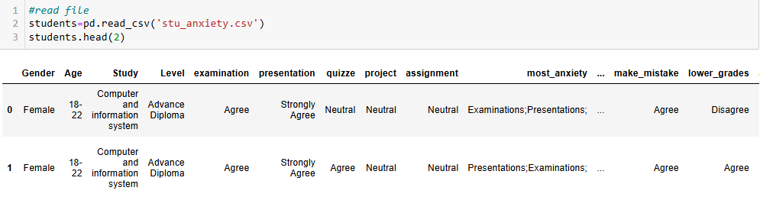
Figure 1
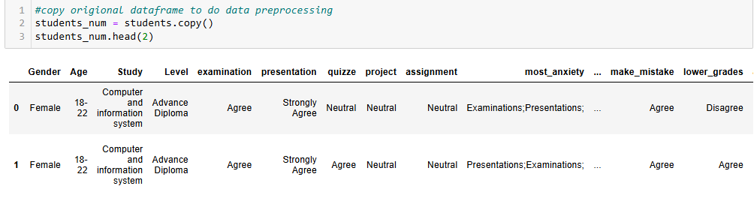
Figure 2
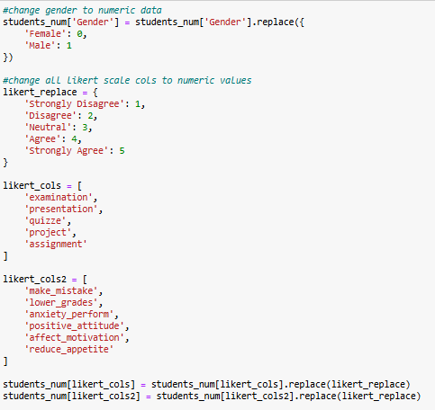
Figure 3
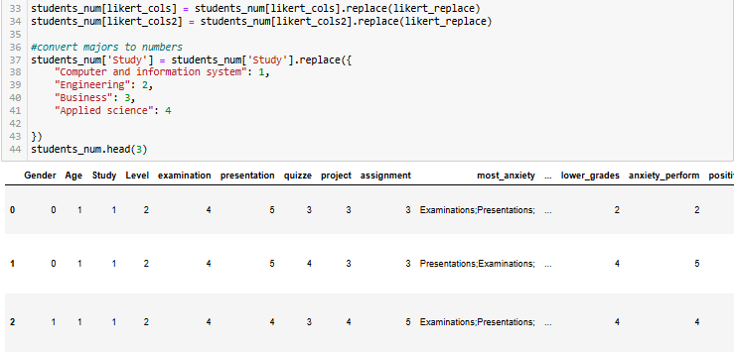
Figure 4
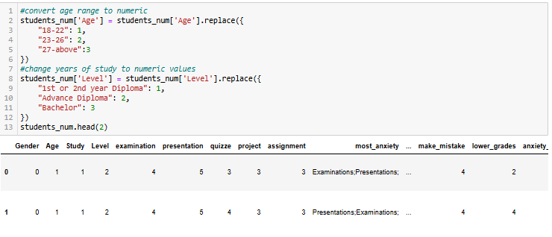
Figure 5
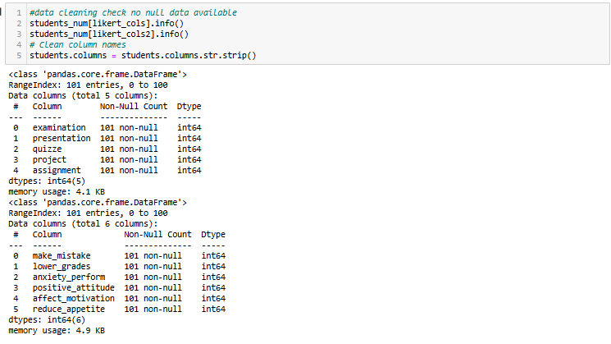
Figure 6

4.2 Descriptive Analysis
Descriptive statistics were used to summarize the demographic characteristics of the participants and the distribution of anxiety-related variables. Frequency and percentage tables were generated for gender, age, study program, and academic level. Measures of central tendency were computed for all Likert-based anxiety variables, including examination anxiety, presentation anxiety, quizzes, projects, and assignments. Students’ selections of the assessments causing them the most anxiety were also analysed. The proportion of students reporting each assessment was calculated, and a combined measure averaging the mean Likert scores and the selection percentages. Bar charts were used to visualize the frequency of coping strategies, support sources, and activities improving well-being.

Table 1 Demographic Distribution of Participants
Category | Subcategory / Item | Frequency | Percentage (%)
Gender
 | Female | 76 | 75.25
 | Male | 25 | 24.75
Age
 | 18–22 | 72 | 71.29
 | 23–26 | 28 | 27.72
 | 27-above | 1 | 0.99
Study
 | Computer and information systems | 64 | 63.37
 | Engineering | 24 | 23.76
 | Business | 7 | 6.93
 | Applied science | 5 | 4.95
 | Business (duplicate entry) | 1 | 0.99
Level
 | Advanced Diploma | 49 | 48.51
 | Bachelor | 27 | 26.73
 | 1st or 2nd year Diploma | 25 | 24.75

Table 2 Distribution of Participants’ Assessment Performance Based on Likert and Overall Scores
Assessment Type | Likert % | Overall % | Combined %
Examination | 81.18% | 38.12% | 59.65%
Presentation | 81.98% | 29.76% | 55.87%
Project | 72.67% | 14.36% | 43.51%
Quiz | 70.69% | 13.36% | 42.02%
Assignment | 63.56% | 4.45% | 34.00%

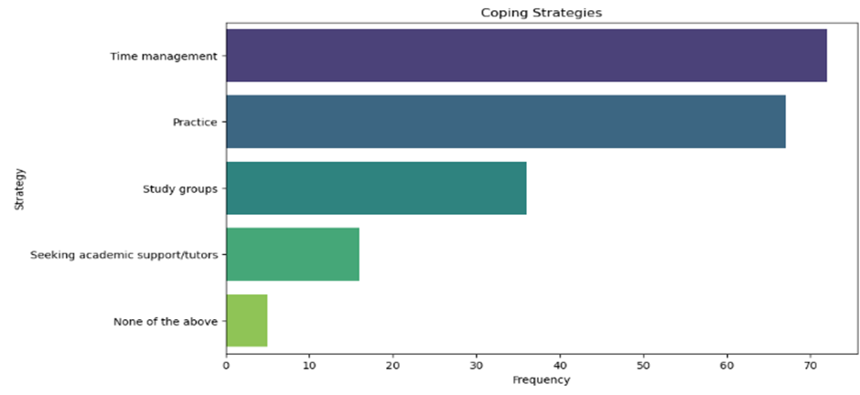
Figure 7
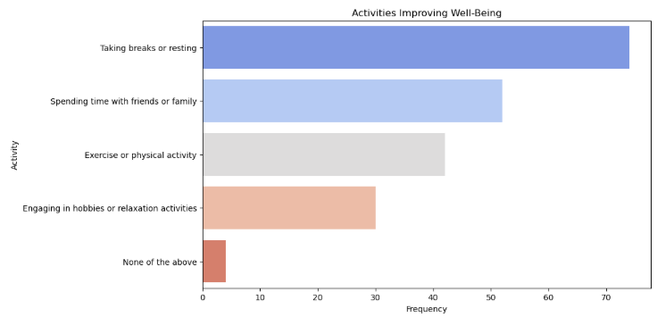
Figure 8
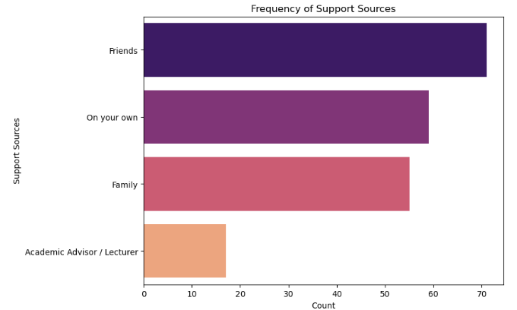
Figure 9

4.3 Inferential Analysis
One-sample t-tests were conducted to examine whether students’ anxiety levels differed from a neutral score of 3 for each assessment type. Multiple linear regression analyses were conducted to identify the factors contributing to anxiety for each assessment. Correlation analysis was used to explore the relationships between assessment anxiety and specific academic or emotional factors.

Table 3 One-Sample T-Test Results of Participants' Assessment Performance
Assessment | Mean Score | T-Statistic | P-Value | Interpretation
Examination | 4.06 | 11.505 | 0.000 | Mean > Neutral → Reject H₀
Presentation | 4.10 | 11.331 | 0.000 | Mean > Neutral → Reject H₀
Quizzes | 3.53 | 5.097 | 0.000 | Mean > Neutral → Reject H₀
Project | 3.63 | 5.597 | 0.000 | Mean > Neutral → Reject H₀
Assignment | 3.18 | 1.702 | 0.092 | Mean ≈ Neutral → Fail to Reject H₀

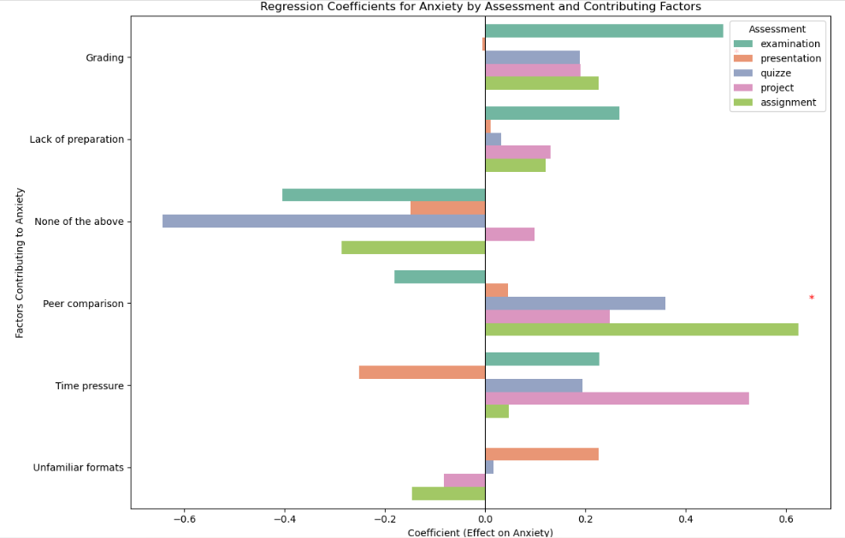
Figure 10

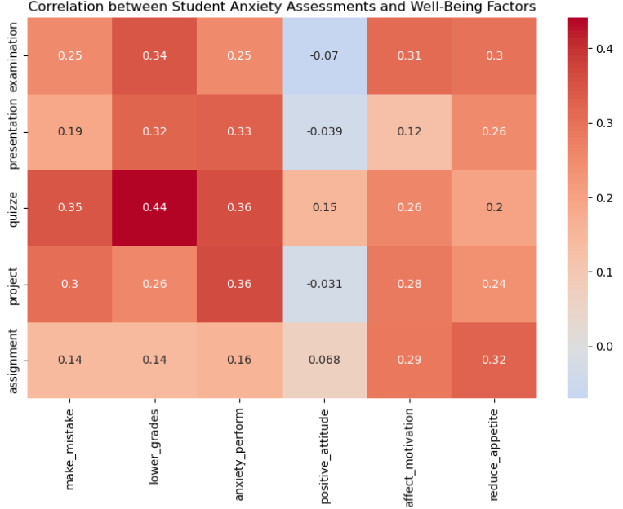
Figure 11

4.4 Presentation of Findings
The descriptive analysis showed that the sample was mostly composed of female students and those aged between 18 and 22 years. The mean scores indicated varying levels of anxiety across assessment types, with examinations showing the highest mean, suggesting that they were the most anxiety-inducing assessments for students. A combined measure, averaging the mean Likert scores and the selection percentages, confirmed that examinations remained the most anxiety-provoking assessment overall.
Students reported a range of strategies to manage assessment-related anxiety. Time management was the most frequently used strategy, followed by practice and participation in study groups, while a few students reported not using any strategy. Support sources primarily included friends, family, or self-management, with fewer students seeking guidance from academic advisors or lecturers. To improve overall well-being during assessment periods, students commonly took breaks or rested, spent time with friends and family, exercised, and engaged in hobbies or relaxation activities. These findings indicate that students employ a combination of personal, social, and practical approaches to manage assessment-related anxiety effectively.
The results of one-sample t-tests showed that examinations, presentations, quizzes, and projects all had mean anxiety scores significantly higher than the neutral value, indicating that these assessments tend to provoke anxiety among students. In contrast, assignments did not differ significantly from the neutral level, suggesting that they generally cause less stress. These results confirm that assessment type has a clear influence on student anxiety levels.
Hypothesis 1
H0.1: There is no difference in anxiety levels in UTAS students doing their assessments.
H1.1: There is a difference in anxiety levels in UTAS students doing their assessments.
Decision: Reject H0.1
Reason: The one-sample t-test results showed that examinations, presentations, quizzes, and projects had mean anxiety scores significantly higher than the neutral midpoint (p < 0.05), indicating elevated anxiety for these assessments. Assignments, however, did not differ significantly from the neutral value (p = 0.092), suggesting they do not contribute substantially to student anxiety. Therefore, anxiety levels vary across some, but not all, assessment types.
Hypothesis 2
H0.2: Elements such as time pressure, grading weight, and unfamiliar assessment formats do not significantly contribute to anxiety during academic assessments.
H1.2: Elements such as time pressure, grading weight, and unfamiliar assessment formats significantly contribute to anxiety during academic assessments.
Decision: Reject H0.2
Reason: Regression analysis revealed that grading pressure, fear of making mistakes, and peer comparison were significant predictors of student anxiety. While some factors, such as unfamiliar formats and time pressure, had weaker or non-significant effects in certain assessments, the presence of multiple significant predictors demonstrates that assessment-related elements contribute meaningfully to anxiety. This demonstrates that students’ cognitive and emotional responses to academic tasks play an important role in shaping their anxiety levels.
Correlation analysis further showed moderate positive correlations between fear of making mistakes, concern over lower grades, and anxiety across assessments, indicating that personal academic concerns are closely linked to increased assessment anxiety. Conversely, positive attitudes and motivation-related factors displayed weaker or negative associations, suggesting that supportive cognitive and emotional traits may help mitigate anxiety.

4.5 Discussion of Findings
The study revealed that examinations and presentations caused the highest anxiety among UTAS students, while assignments were less stressful. This supports the hypothesis that performance-based assessments trigger greater anxiety. However, the expectation that demographic factors such as age or field of study would significantly influence anxiety was not confirmed, suggesting that internal academic concerns play a more critical role.
Personal concerns, such as fear of mistakes, worries about lower grades, and performance anxiety, were strongly associated with overall anxiety, aligning with the cognitive interference model (Rana & Mahmood, 2010). These findings also correspond with (Mirawdali et al., 2018), who reported that performance-oriented assessments increase anxiety, and (Ismail et al., 2022), who found that formative, feedback-rich assessments reduce anxiety compared to high-stakes evaluations.
Future research could study how student anxiety changes over time and examine ways to reduce it, such as giving feedback during learning, using technology, or giving clear instructions for assessments. Studies could also look at students’ personal experiences, including how gender or culture affects their anxiety.
In summary, academic tasks, especially examinations and presentations, are major sources of anxiety, with personal academic concerns driving student anxiety. The key takeaway is that implementing supportive and flexible assessment practices can reduce anxiety, enhance performance, and promote overall well-being.

Chapter 5: Conclusion and Recommendations

5.1 Conclusion
This study is set out to examine which academic assessments cause the highest levels of anxiety among UTAS students, as well as how this anxiety influences their academic performance and well-being. The research confirmed that examinations and presentations are the most anxiety-provoking assessment types, with both showing significantly higher anxiety scores compared to neutral levels. Projects and quizzes also triggered moderate anxiety, while assignments were found to cause the least stress.
The findings showed that internal academic concerns, such as fear of making mistakes, pressure to achieve high grades, and performance anxiety, were the strongest predictors of overall anxiety. These results support both the Cognitive Appraisal Theory and previous literature emphasizing that students’ subjective evaluation of academic tasks determines their emotional response.
The significance of the study lies in identifying key assessment-related triggers of anxiety within UTAS, highlighting the importance of supportive assessment design. This research emphasizes the need for institutions to adopt more balanced, transparent, and student-friendly evaluation practices to enhance academic performance and student well-being. In conclusion, this research provides clear evidence that academic anxiety is a critical issue among UTAS students and demonstrates that thoughtfully designed assessments and targeted support strategies can effectively mitigate anxiety, improve performance, and promote overall psychological well-being.

5.2 Contributions of the Study
This study provides significant contributions to understanding academic anxiety among university students, particularly in the context of Omani higher education at UTAS Muscat. While test anxiety has been widely studied internationally, few studies focus on the unique cultural, institutional, and educational environment of Oman. The research addresses this gap by examining the specific relationship between different academic assessments and student anxiety, exploring how these emotional responses impact performance and well-being. The study also identifies coping strategies, offering practical insights for improving assessment design and student support.
First, the study fills a notable research gap by investigating assessment-specific anxiety in UTAS Muscat, an underrepresented context in existing literature. International studies often report mixed results regarding which assessments induce the most anxiety, yet local educational culture, teaching methods, and student expectations can profoundly influence these outcomes. By focusing on UTAS, this research provides contextually relevant data, offering a localized understanding of academic anxiety and helping bridge the gap between global research and Omani higher education practices.
Second, the study contributes new observed evidence showing that examinations and presentations are the most anxiety-provoking assessments among UTAS students. Projects and quizzes generate moderate anxiety, while assignments typically induce lower stress. This contrasts with some international findings, where the hierarchy of assessment-related anxiety varies. By quantifying the anxiety levels for each assessment type, the research highlights how specific academic tasks can trigger emotional responses differently, providing actionable insights for educators seeking to design assessments that balance thoroughness with student well-being.
Third, the findings reveal that personal academic concerns such as fear of making mistakes, pressure to achieve high grades, and performance anxiety are more influential than demographic characteristics in predicting student anxiety. Age, gender, and field of study had minimal impact on overall anxiety levels. This underscores the importance of mental and emotional factors in academic anxiety, supporting existing theories such as the Cognitive Appraisal Theory. The research thus reinforces the idea that interventions should focus on internal perceptions and pressures rather than solely on external demographic variables.
Fourth, the study provides practical insights into coping strategies commonly employed by students. Techniques such as time management, practice-based preparation, peer support, and taking breaks were frequently reported as effective methods for managing assessment-related anxiety. By identifying these strategies, the research informs institutional policies and student-support initiatives, allowing UTAS to develop targeted programs that align with students preferred coping mechanisms. This contribution demonstrates how understanding student behavior can directly improve academic support and mental well-being.
Overall, this research offers a structured, data-driven understanding of assessment-related anxiety in an underexplored educational context. It provides clear evidence of which academic tasks and personal concerns contribute most to anxiety and outlines practical solutions for mitigation. By integrating both theoretical and observed insights, the study informs future research, guides supportive assessment design, and emphasizes the importance of student-centered interventions. In essence, the findings support a more balanced, transparent, and culturally sensitive approach to assessments, promoting both academic success and psychological well-being for students in Omani higher education.

5.3 Recommendations for Future Research
Based on the findings and limitations of this study, several avenues for future research are recommended. These suggestions aim to expand knowledge on assessment-related anxiety, test interventions, and explore the applicability of existing theoretical frameworks in the Omani higher education context.
Longitudinal Studies on Anxiety Patterns
Future research could track anxiety levels across an academic semester, particularly before midterms and finals. This would build on the current finding that anxiety peaks around high-stakes assessments and provide deeper insights into how anxiety fluctuates over time. Such studies could also test whether interventions implemented early in the semester are effective in mitigating anxiety later.
Exploring Specific Sources of Anxiety in Examinations and Presentations
Since examinations and presentations were identified as the most anxiety-provoking tasks, future studies could investigate underlying factors, such as time pressure, unfamiliar assessment formats, public speaking fears, or cognitive workload. This would refine the understanding of specific triggers and inform more targeted interventions.
Testing Interventions to Reduce Assessment Anxiety
Future research could evaluate the effectiveness of strategies such as formative assessments, relaxation and mindfulness training, structured feedback, peer-support workshops, or technology-assisted assessments. These studies could explicitly test theoretical frameworks, such as Cognitive Appraisal Theory, to determine which strategies most effectively reduce anxiety in students.
Expanding Research to Other UTAS Branches or Omani Institutions
Comparative studies across different campuses or institutions would examine whether assessment-related anxiety varies by campus culture, departmental teaching methods, or regional educational practices. This would address the current study’s limitation of focusing on a single campus and provide evidence for the generalizability of findings.
Examining the Role of Technology in Reducing Anxiety
With the global shift toward digital learning, future studies could explore whether tools such as online exams, automated feedback, virtual presentations, or adaptive learning platforms help reduce anxiety. Research could also evaluate how technology-based interventions interact with students’ personal coping strategies.
Incorporating Qualitative Methods
Interviews, focus groups, or diary studies could provide deeper insights into students lived experiences, uncovering emotional and psychological factors that surveys alone cannot capture. Qualitative research could also test and refine theoretical models of academic anxiety in the Omani higher education context.
Re-evaluating and Expanding Theoretical Frameworks
Future studies could revisit existing models of academic anxiety, such as Cognitive Appraisal Theory or performance-based stress frameworks, to assess their relevance in the Omani higher education environment. They could also expand these theories by integrating cultural, institutional, and technological factors that influence assessment-related anxiety.
Conclusion:
Overall, these recommendations emphasize a combination of longitudinal, comparative, intervention-based, and qualitative research approaches. Implementing these suggestions would deepen understanding of assessment-related anxiety, inform evidence-based interventions, and help design supportive assessment practices to enhance student well-being and academic performance in Oman.

5.4 Implications/Limitations of Research
This study contributes to the academic understanding of assessment-related anxiety in higher education by highlighting the differential impact of various assessment types, particularly examinations and presentations, on student anxiety. It supports and extends Cognitive Appraisal Theory, showing that students’ subjective evaluation of tasks and internal academic concerns (fear of mistakes, grade pressure, performance anxiety) are stronger predictors of anxiety than demographic factors. The findings also provide opportunities to refine existing theories of academic anxiety by integrating cultural and institutional influences specific to the Omani higher education context. Furthermore, the study introduces practical considerations, such as coping strategies and institutional support measures, into the theoretical discussion of academic anxiety.
The results offer several actionable insights for educators and university administrators. Implementing supportive assessment practices, such as clear instructions, flexible deadlines, reduced workload, formative assessments, and practice opportunities, can mitigate student anxiety. Providing a calm, structured, and supportive environment during exams and presentations can enhance both student performance and well-being. Institutions can also design targeted interventions, such as time management workshops, relaxation techniques, peer-support programs, and early announcement of assessments, based on students’ reported strategies. These findings can inform policy decisions, curriculum design, and mental health support initiatives in higher education.
Despite its contributions, the study has several limitations. First, the research was conducted at a single UTAS campus, which may limit the generalizability of findings to other campuses or institutions in Oman. Second, the study primarily relied on self-reported survey data, which may be subject to response bias or inaccurate recall. Third, the cross-sectional design captures anxiety at a single point in time and does not account for fluctuations across the academic semester. Finally, while qualitative responses provided rich insights into coping strategies, they were not exhaustively explored through in-depth interviews or longitudinal tracking, which could offer a deeper understanding of students lived experiences.

References
Al Husaini, Y., & Shukor, N. (2023). (PDF) Factors Affecting Students’ Academic Performance: A review. https://www.researchgate.net/publication/367360842_Factors_Affecting_Students'_Academic_Performance_A_review
Cassady, J. C., Tan, S. H., Robiullah, A., Badzovski, I., & Janiuk, J. (2025). Methods Employed in Studies Identifying “Levels” of Test Anxiety in University Students: A Systematic Review. Behavioral Sciences, 15(3), 331. https://doi.org/10.3390/bs15030331
Elbourhamy, D. M. (2025). Automated evaluation systems to enhance exam quality and reduce test anxiety. PeerJ Computer Science, 11, e2666. https://doi.org/10.7717/peerj-cs.2666
Frias-Navarro, D., Monterde-i-Bort, H., Navarro-Gonzalez, N., Molina-Palomero, O., Pascual-Soler, M., PerezGonzalez, J., & Longobardi, C. (2018). Statistics anxiety in university students in assessment situations. Proceedings of the 4th International Conference on Higher Education Advances (HEAd’18), 1–8. https://doi.org/10.4995/HEAD18.2018.7990
Hull, K., Lawford, H., Hood, S., Oliveira, V., Murray, M., Trempe, M., Crooks, J., Richardson, M., & Jensen, M. (2019). Student Anxiety and Evaluation. Collected Essays on Learning and Teaching, 12, 23–35. https://doi.org/10.22329/celt.v12i0.5409
Ismail, S. M., Rahul, D. R., Patra, I., & Rezvani, E. (2022). Formative vs. summative assessment: Impacts on academic motivation, attitude toward learning, test anxiety, and self-regulation skill. Language Testing in Asia, 12(1), 40. https://doi.org/10.1186/s40468-022-00191-4
Md. Fajlay Rabbi & Md. Sefatul Islam. (2024). The Effect of Academic Stress and Mental Anxiety among the Students of Khulna University. Edukasiana: Jurnal Inovasi Pendidikan, 3(3), 280–299. https://doi.org/10.56916/ejip.v3i3.723
Meng Chuan, H., Chye Ying, L., Khong Yun, P., Pei Boon, O., & Kay Hooi, K. (2022). ACADEMIC STRESS AND ANXIETY AMONG UNDERGRADUATE STUDENTS IN MALAYSIA. International Journal of Education, Psychology and Counseling, 7(46), 98–109. https://doi.org/10.35631/IJEPC.746009
Mirawdali, S., Morrissey, H., & Ball, P. (2018). ACADEMIC ANXIETY AND ITS EFFECTS ON ACADEMIC PERFORMANCE.
Rana, R. A., & Mahmood, N. (2010). RELATIONSHIP BETWEEN TEST ANXIETY AND ACADEMIC ACHIEVEMENT.
Summary of Lazarus and Folkman’s Theory of stress, appraisal, and coping—Jokogunawan.com. (n.d.). Retrieved December 5, 2025, from https://jokogunawan.com/summary-of-lazarus-and-folkmans-theory-of-stress-appraisal-and-coping/

Appendices
A.1 Questionnaire
This study uses a survey administered to UTAS students, designed to collect data across four sections: Demographics, Student Anxiety Levels and Causes, Academic Performance & Well-Being, and Coping Strategies and Support. Each section corresponds directly to one of the research objectives, enabling comprehensive analysis and insights into students’ experiences with academic anxiety and related factors.
